**MongoDB Task**

**Design database for Zen class** **programme:**

1. Find all the topics and tasks which are thought in the month of October.

**Solution:**

db.topics.aggregate([

    {$match: {class_date: {$gte: ISODate("2020-10-01"),$lt: ISODate("2020-11-01")}}},

    {$lookup: {from: "tasks", let: { topic: "$topic", class_date: "$class_date" }, pipeline: [

          {

            $match: {$expr: {$and: [{ $eq: ["$topic", "$$topic"] },{ $gte: ["$task_date", "$$class_date"] },

             { $lt: ["$task_date", { $add: ["$$class_date", 1 * 24 * 60 * 60 * 1000] }] }]}}

          }

        ],

        as: "tasks"}

    }

  ]);

**Rusult:**

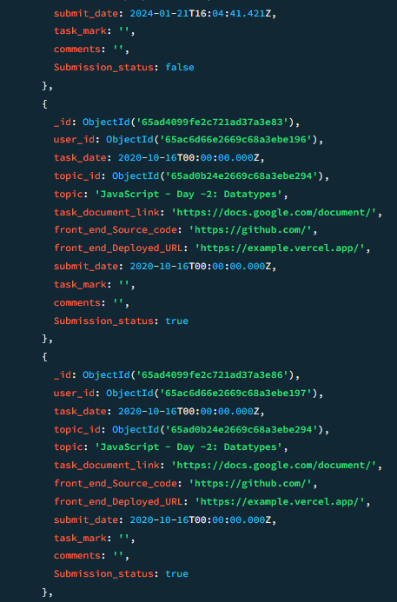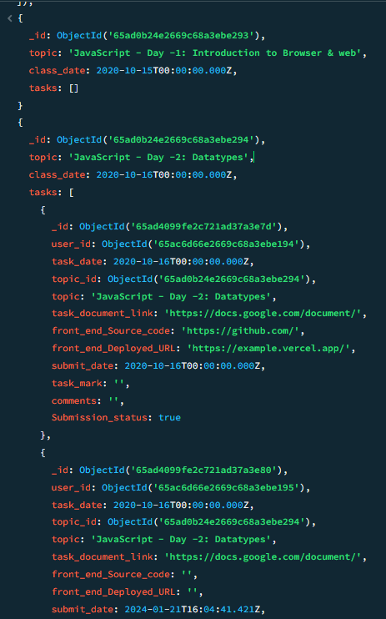 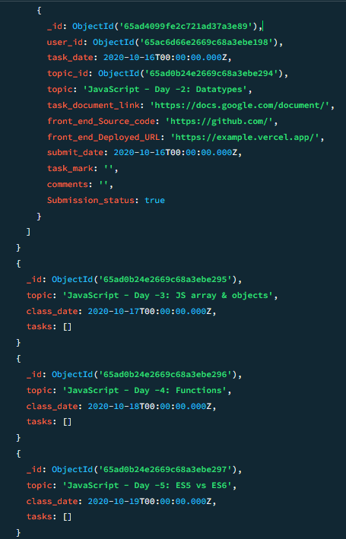

1. Find all the company drives which appeared between 15 oct-2020 and 31-oct-2020.

**Solution:**

db.companydrives.find(

    {drive_date: {$gte: ISODate("2020-10-15"), $lte: ISODate("2020-10-31")}},

    {_id:0, company:1, drive_date: 1}

    )

**Result:**

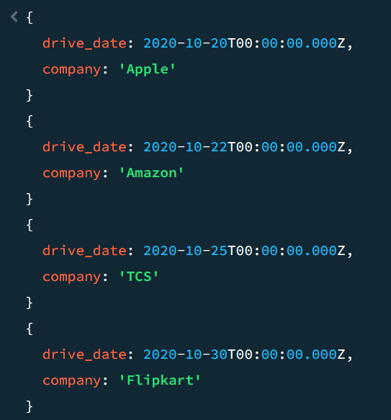

1. Find all the company drives and students who are appeared for the placement.

**Solution: Result:**

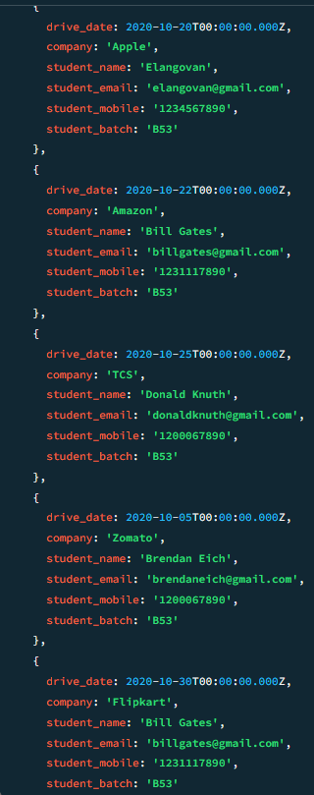db.companydrives.aggregate([

    {$lookup: {from: "users", localField: "user_id", foreignField: "_id", as: "studentInfo"}},

    {$unwind: "$studentInfo"},

    {$project: {_id: 0, drive_date: 1, company: 1,   student_name: "$studentInfo.name",

            student_email: "$studentInfo.email",

            student_mobile: "$studentInfo.mobile",

            student_batch: "$studentInfo.batch"

        }

    }

])

1. Find the number of problems solved by the user in codekata.

**Solution:**

db.codekata.aggregate([

  { $group: {_id: "$user_id",  totalProblemsSolved: { $sum: "$Total_solved" } } },

  { $lookup: {from: "users", localField: "_id", foreignField: "_id", as: "userDetails"} },

  { $unwind: "$userDetails" },

  { $project: {_id: 0, userName: "$userDetails.name", totalProblemsSolved: 1}

  }

]);

**Result:**

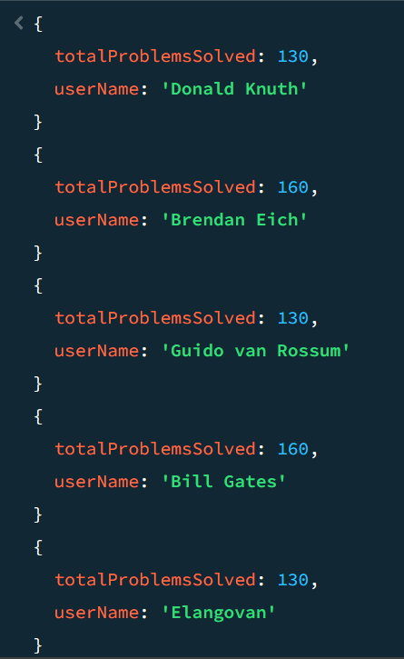

1. Find all the mentors with who has the mentee's count more than 15.

**Solution:**

db.mentors.find(

  { mentee_count: { $gte: 15 } },

  { _id: 0, mentorname: 1, mentee_count: 1 }­­­

);

**Result:**

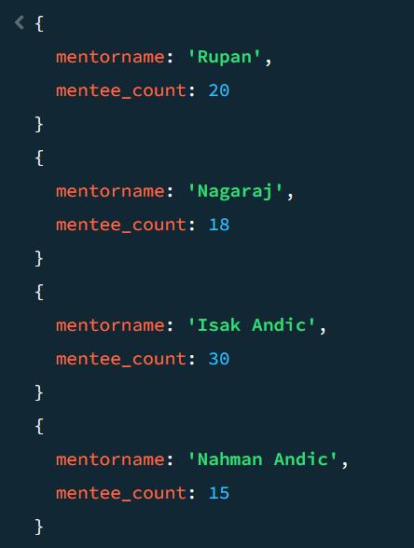

1. Find the number of users who are absent and task is not submitted  between 15 oct-2020 and 31-oct-2020.

**Solution:**

db.attendance.aggregate([

    {$match: {date: {$gte: ISODate("2020-10-15"), $lte: ISODate("2020-10-31")}, status: false}},

    {$lookup: {from: "tasks", localField: "user_id", foreignField: "user_id", as: "taskInfo"}},

    {$match: {"taskInfo": { $elemMatch: {task_date: {$gte: ISODate("2020-10-15"), $lte: ISODate("2020-10-31")},

    Submission_status: false}}}},

    {$group: {_id: null, count: { $sum: 1 }}}

  ])

**Result:**

{

_id: null,

count: 3

}